Message from HKU Trading Group Quant Team
To Applicants,

Thank you for your interest in HKU Trading Group Quant Team.

You are now invited to complete a test. Please find below the instructions for the two required questions and one optional question. There is no required completion time but please return your work by submitting to this form with clearly indicating which track you are applying to by 11:59p.m., Sep 22, 2025 (Mon).

We wish you best of luck.

Best regards,
HKU Trading Group Quant Team

Question 1 - Code Understanding
Question Statement
Explain the mathematical interpretation of the above codes

Requirement
- A short response within 50 words
The code computes the number of unit cubes on the surface of a n x n x n cube.
F = 8 (corners) + 12(n-2) edges + 6(n-2)^2 faces
n = 1, 1 cube.
n = 2, 8 cubes
n = 3, 26 cubes
n = 4, 56 cubes
Submission
- Paste your answer in the form


Question 2 - Coding
Question Statement:
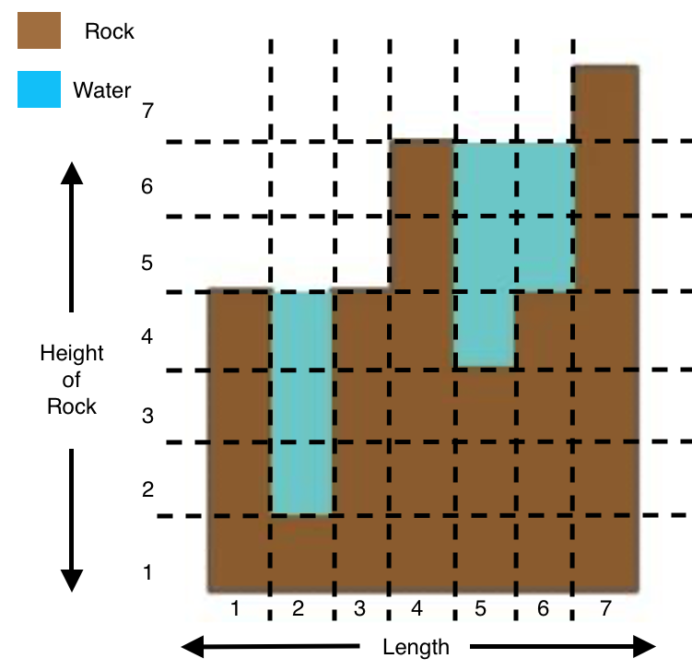
This is a canyon. Brown represents rocks, blue represents water. There was heavy rain last week and water was trapped in the canyon. Calculate the volume of water under the canyon in unit cubed.
Input Format
- The first line of the input contains an integer L, the length of the Canyon [1, 30000]
- The next L lines each contains one integer h_i, the height of the rocks at position i [0,10000]

Requirement
- Runtime limit: 1000ms
- Memory limit: /
- Language: Python or C++
- No external library can be used. Meanwhile, standard libraries such as the Python math module are allowed.

Submission
- 1 .py file or 1 .cpp file
- Rename the file to HKUTG_2025_Quant_Application_Developer_Q2_{Your name}.py OR HKUTG_2025_Quant_Application_Developer_Q3_{Your name}.cpp
Sample Case
Input:
7
4
1
4
6
3
4
7

Output:
8

Sample Case Explanation
We can see that there are 8 units of water trapped in the Canyon.

Question 3 - Explosory Data Analysis (Optional)
Please note that it is not compulsory to complete this question. Meanwhile, for applicants who successfully completed this question with high quality response, you will be prioritised in moving into next round

In this question, you will be required to explore insights from the Hong Kong daily passenger dataset which can be downloaded from here.

Requirement
- You must use .ipynb to explore the dataset with outlining your code in completing the question
- Allowed external libraries: Pandas, matplotlib

Hint
Note that there is no standard correct/ wrong answer to this question. You are encouraged to explore the data, come up with a focus, and try your best to extract interesting insights.

Submission
- 1 .ipynb file
- Rename the file to HKUTG_2025_Quant_Application_Developer_Q3_{Your name}.ipynb
- An one pager summarising all of your findings

END OF TEST
ABOUT HKU TRADING GROUP
Founded in 2020, HKU Trading Group is the premier student finance organization at The University of Hong Kong. In addition to opportunities to conduct investment research as an undergraduate, HKU Trading Group offers students an unrivalled mentorship and networking opportunities with current and former members who have held offers/roles at top financial institutions.

MORE INFORMATION / ENQUIRIES
For more information on the test, please reach out to hkutradingclub@gmail.com.

